Metrics Baseline Report 1022

Jul 2022-Sep 2022

OCT 4, 2022

Genus Innovation Limited

Process Engineering Group

Approved By: Tarun Gupta

Contents

Introduction 3

Scope 3

References 3

Tools Used 3

Metrics and Goals 3

Terminology 5

Metrics 6

Schedule Variance 6

Definition 6

Input 6

Chart and Analysis for Completed Projects 6

Chart and Analysis for On-going Projects 7

Conclusion and Proposed Corrective & Preventive Actions 12

Line Rejection Percentage 12

Definition 12

Input 12

Chart 12

Analysis 13

Conclusion and Proposed Corrective & Preventive Actions 13

Process engineering group 13

Process Quality Assurance 14

Input 14

Chart July 2022 14

Analysis July 2022 14

Chart Sep. 2022 15

Analysis Sep. 2022 15

Conclusion and Proposed Corrective & Preventive Actions 16

Product Quality Assurance 16

Input 16

Chart and Analysis 16

Conclusion and Proposed Corrective & Preventive Actions 18

Organizational Training 18

Input 18

Chart & Analysis 18

Conclusion and Proposed Corrective & Preventive Actions 21

# Introduction

This Metrics Baseline Report, henceforth referred to as MBR, is a report to present and analyse the performance of the Research and Development division at Genus Innovation Limited in quantitative terms. This Report is also intended to be a driver for process improvements going forward. This can be a guide to detecting potential issues related to the process effectiveness and performance.

This Report covers the period from Jul. 2022 to Sep. 2022. GGE300 & GGE295 projects completed in this duration and all products produced in this duration are covered in this report.

# Scope

This MBR presents the measurements of projects and produced products as discussed above. It tries to gauge the performance of the organization in terms of Schedule adherence and Quality of products produced for customer.

# References

Measurement and Analysis Procedure (PRCD_MEASUR) as in QMS 4.1

Business Objective to Process Objective Mapping (MSTL_BOTOPO) as in QMS 4.1

# Tools Used

Data Collection, Measurement, Analysis and Reporting Tool of GIL.ef[1].

# Metrics and Goals

|  |  |  |
| --- | --- | --- |
| **Objectives/Approach** | **Associated Metrics** | **Goal** |
| To reduce the number of functional defects in the product delivered to the customer | Line Rejection Ratio  Line rejection percentage is the ratio of total line failures in a month and the total quantity produced in the month.. | Goal : 2.5%  USL & LSL : ±5% |
| To reduce Schedule Variance from the project’s planned schedules | Schedule Variance  Schedule Variance measures the difference between scheduled and achieved durations for a project. | Goal : 0  USL & LSL : ±20% |

# Terminology

USL and LSL

USL and LSL stand for Upper Specification Limit and Lower Specification Limits respectively. These are the maximum and minimum permissible values of the parameter under consideration. The difference between USL and LSL is called the specification range.

Deviation

Deviation of a parameter refers to the difference in the value with respect to its specified values. This is usually expressed as a ratio.

Variance

The variance is used as a measure of how far a set of numbers are spread out from each other.

# Metrics

## Schedule Variance

The purpose of this measurement is to reduce Schedule Variance from the Project’s planned duration (Project Start to Project Closure). This takes only closed project in consideration.

### Definition

Schedule Variance measures the difference between scheduled and achieved durations for a project.

The Schedule Variance of a project is

((Actual Project Duration - Planned Project Duration)/ Planned Project Duration)

### Input

* Data Collection, Measurement, Analysis and Reporting Tool of GIL.ef[2]. The data is from the Project Reports in EinFrame. The planned start and end dates are taken from project planning. Actual start and end dates are updated when that particular gate is approved in EinFrame. So the ratio of actual minus plan and plan is schedule variance, which is automatically calculated in Project Reports of EinFrame.

### Chart and Analysis for Completed Projects

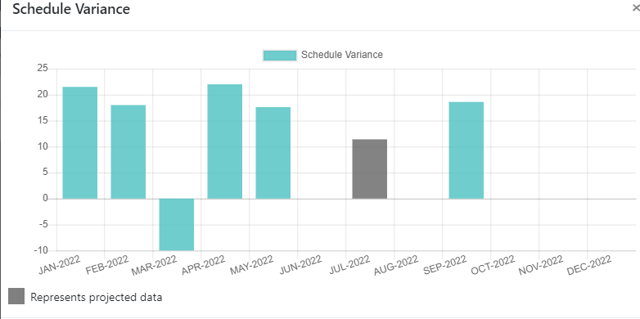



The Schedule variance chart for completed projects i.e. GGE295 & GGE300 as above indicates that although the schedule variation is under limit, but near the upper limit. This is due to the release related activities that were extended by one week.

### Chart and Analysis for On-going Projects

The chart & analysis mentioned for on-going projects in two terms, one as per data come in EinFrame’s Project Report till last approved gate, and second is as per data presented in last Metrics Report.

1. **GGE302**

*The Project Report including recent gate closure from EinFrame, the schedule variance showing “0”.*

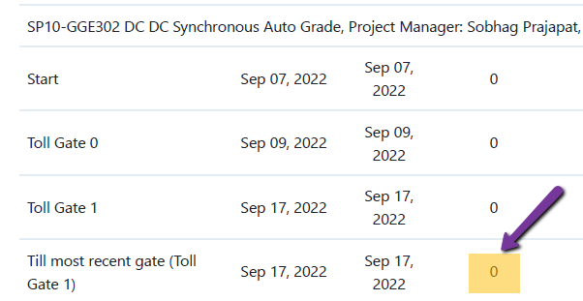

*And as per last metrics report prepared by project manager to present to SM, the project is getting delayed by approx. 2 days. To overcome this delay they gave buffer in design phase to complete the pending tasks.*

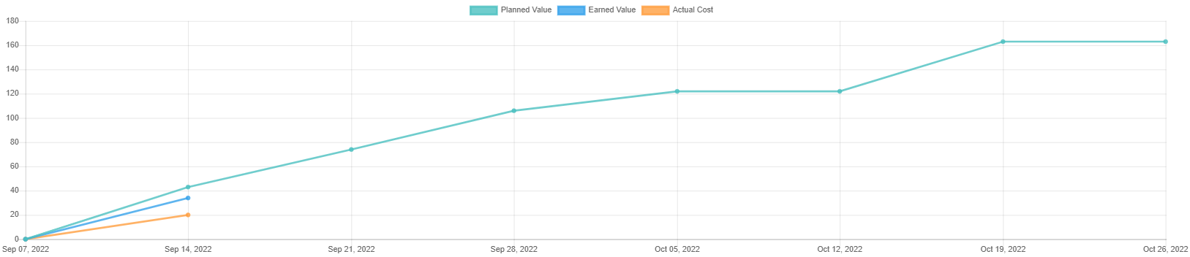

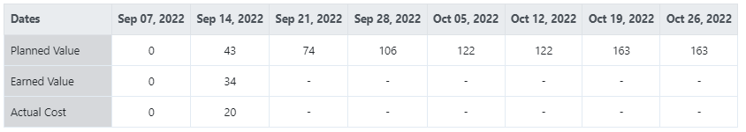

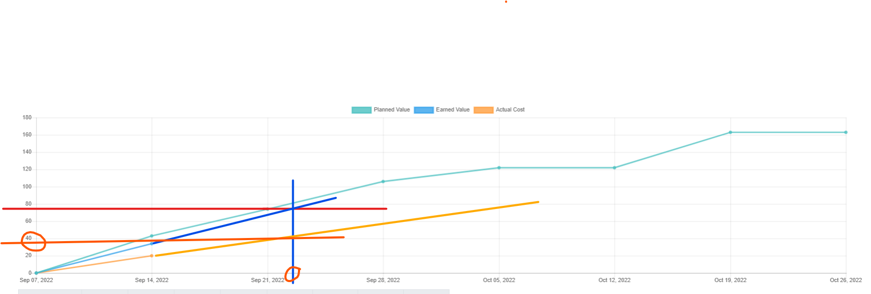

1. **GGS151 :**

*The Project Report including recent gate closure from EinFrame, the schedule variance showing “13.33%” in positive side.*

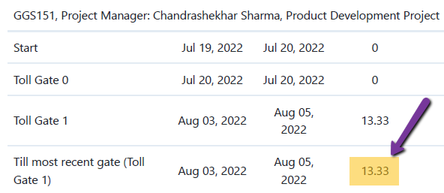

And as per last metrics report prepared by project manager to present to SM, the project is getting delayed.

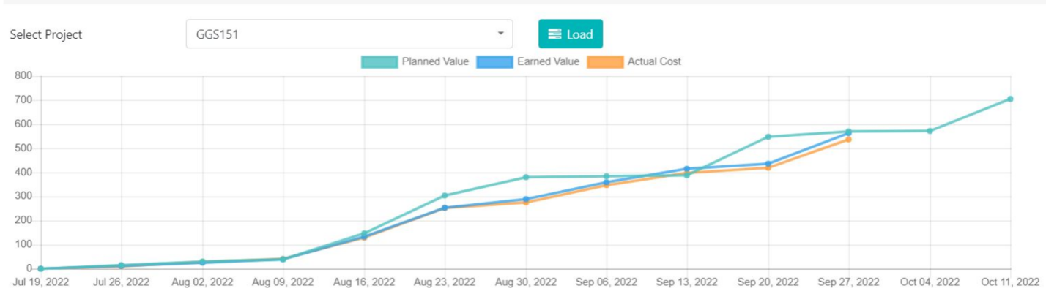

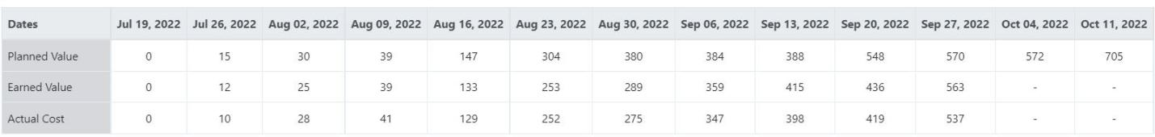

**RD and Planning Phase:**  The schedule variance at the end of TG1 (RD and Planning phase) is 13.33% which was under limit.

**Design Phase:**  The schedule variance at the end of Design Phase is 23.94% which is out of limit, as in this phase basically 2 things occurred:

1. Due to some holiday comes in weekend so more team member takes leave without planning.
2. Firmware designer and Reviewer also busy in other projects.

**Integration Phase:** The schedule variance at the end of Integration Phase is 6.9% which is under limit, in this phase basically 2 things occurred:

1. Two team members resigned, so new team members took some time to understand product.

2. BOM upload in SAP task also delayed due to some unplanned leave taken by team members.

For these delays project manager arranged team meeting and decided to give extra efforts to overcome the schedule delays.

1. **GGE289**

*The Project Report including recent gate closure from EinFrame, the schedule variance showing “9.09%” in positive side.*

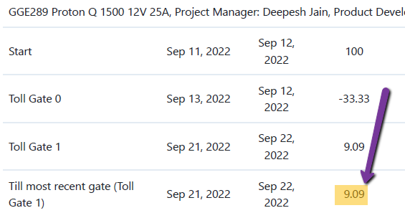

And as per last metrics report prepared by project manager to present to SM, the project is on time.

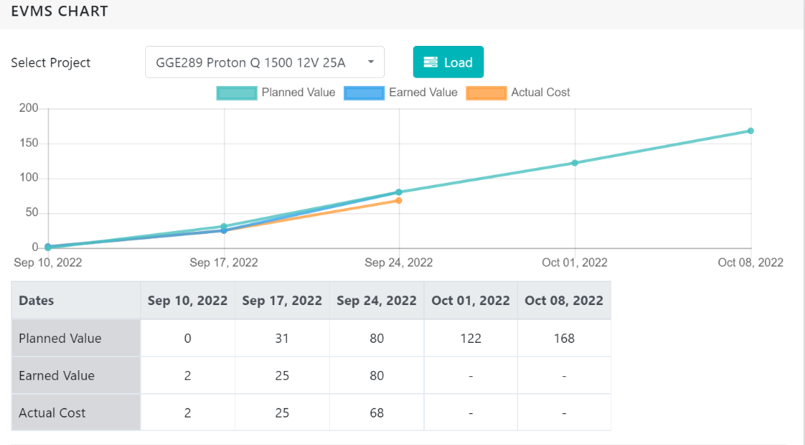

The schedule variance at the end of the Toll Gate 1 was 9.09% which was under limit but actually behind from plan.And when project manager checked the reason of this variance then he found that, Project manager was on leave for 1 day. So the planned work was not completed on that day. That was compensated in next phase by taking necessary actions and now project is on time.

1. **OBH012**

*The Project Report including recent gate closure from Einframe, the schedule variance showing “0%”.*

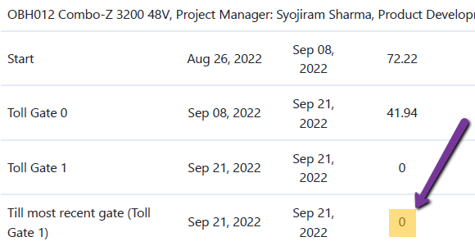

And as per last metrics report prepared by project manager to present to SM, the project is ahead by approx. 2 days.

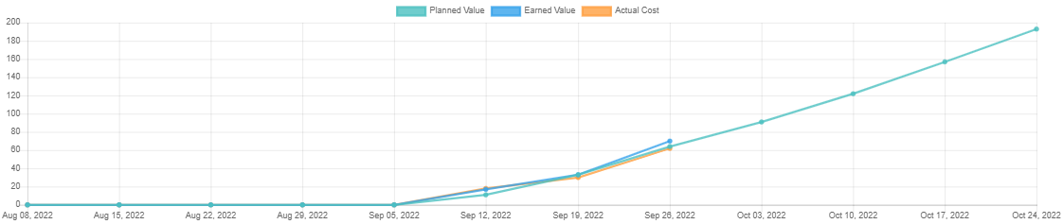

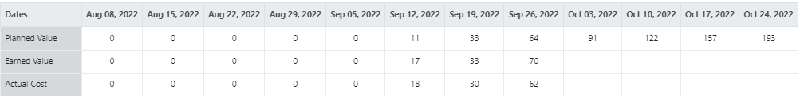

### Conclusion and Proposed Corrective & Preventive Actions

The suggestions for future may be

* Conveyed to PM that consolidate the all required activities during release and consider during planning.
* PEG conveyed that whenever long weekend or some holidays of more than 2 days come, the surrounding day’s buffer should consider in planning, as may be team members take leaves on that days. Either asks from team well before about their planning or take buffer in plan, so that the unexpected delays cannot be occurred. As PEG we’ll add understanding as point in planning guidelines.
* Regular processes adherence & improvement meetings occurring.
* Understanding sessions on Einframe already taken.

## Line Rejection Percentage

The purpose of this measurement is to reduce the number of defects in the products being manufactured..

### Definition

Line rejection percentage is the ratio of total line failures in a month and the total quantity produced in the month.

### Input

Google sheet” [HI**P Rejection Report Inverter**](https://docs.google.com/spreadsheets/d/1hZkQ-jFMYuwxKOEk1bhY1y_m4h4pu6LMp2X3Ta1-XYo/edit?usp=sharing)” fill by Production-Quality team with line failures and total quantity produced aggregated over the month. The total produced quantity can be verified by SAP transaction”**MB51**”and Mr. Subhash Chand (QA Head) verifies the rejection quantity.

### Chart

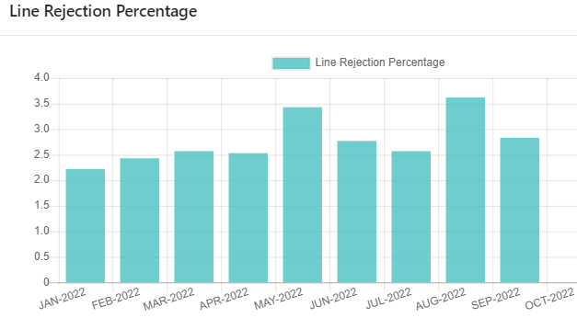

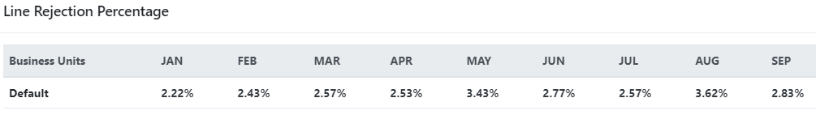

### Analysis

The line rejection percentage got as average 2.77% for these 9 months and average 3% for last 3 months (Jul-Sep.22). Overall that is actually good figure with respect to goal taken. But in last 6 months especially in May & Aug. it went near to 3.5%. This is due to

1. *Chint make MCBs created quality issues like MCB dolly free. This high failure expected because engineering sample approved for trial lot.*
2. *Another reason is that some random failure in existing running MOSFETs during line testing.*

### Conclusion and Proposed Corrective & Preventive Actions

Although data are coming under limit, due to recently taken actions on some components which were relatively more failure rate during production. Like Transistor BC547 replaced by BC337.25 and MOV 14mm replaced by MOV 20mm. But for above two reasons, below are some corrective and preventive actions taken:

1. As corrective action since trial lot results are not satisfactory Chint make MCBs hold for further mass use. Although trial lot event itself is preventive action before mass, but more sampling proposed in R&D and IQC/QA parallel in future.
2. New MOSFETs makes as alternate exploring for more reliability as well as for cost effective, like Rectron, Semihow etc.
3. The BOM review checklist will introduce in QMS considering these points.

# Process engineering group

PEG has released major version of QMS to align with Einframe, simplified and removed duplication and significant reduction in forms and templates (approx. 19 artefacts).

PEG has released one minor version also to address the improvement proposal as well as findings in IR-1.

As Benchmark Appraisal scheduled in Nov.22 first week, so one major is version expected after that to address appraisal’s findings.

# Process Quality Assurance

### Input

The data takes from Audit Report made by PQA Head. Although PQA itself checks all data, but PEG also verifies the report data using Incident Management Report in EinFrame.

### Chart July 2022

### Analysis July 2022

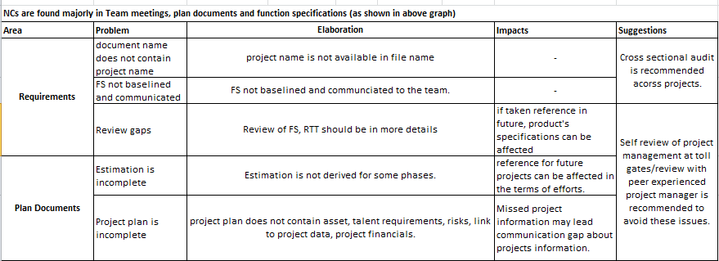

### Chart Sep. 2022

### Analysis Sep. 2022

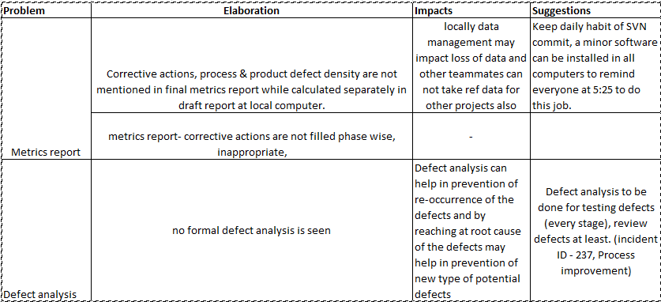

### Conclusion and Proposed Corrective & Preventive Actions

1. *Cross functional audit is recommended across projects.*
2. *Project managers proposed to attend the audits of other project manager’s project audit for better understanding as well as this will be helpful to make auditors pool.*
3. *Cultural enhancements required in team members regarding self-review, timely commit works in corresponding repositories (server version controlled system).*
4. *In process point of view will explore for guidelines to identify the critical defect / issue for analysis instead of random selection.*

# Product Quality Assurance

### Input

The data takes from Incident Management Report site of Einframe.

### Chart and Analysis

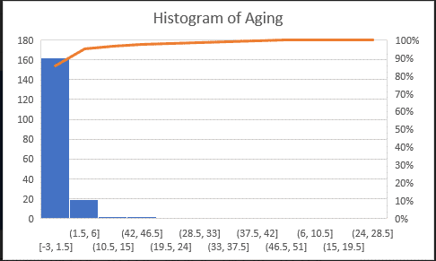

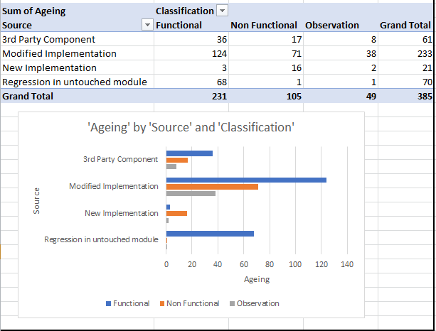

|  |  |  |
| --- | --- | --- |
| **Source** | **Classification** | **Sum of Effort Spent** |
| **3rd Party Component** | Functional | 18 |
| **3rd Party Component** | Non Functional | 3 |
| **3rd Party Component** | Observation | 0 |
| **3rd Party Component Total** |  | **21** |
| **Modified Implementation** | Functional | 3 |
| **Modified Implementation** | Observation | 1 |
| **Modified Implementation** | Non Functional | 0 |
| **Modified Implementation Total** |  | **4** |
| **New Implementation** | Functional | 0 |
| **New Implementation** | Observation | 0 |
| **New Implementation** | Non Functional | 0 |
| **New Implementation Total** |  | **0** |
| **Regression in untouched module** | Observation | 1 |
| **Regression in untouched module** | Non Functional | 1 |
| **Regression in untouched module** | Functional | 0 |
| **Regression in untouched module Total** |  | **2** |
| **Grand Total** |  | **27** |

1. *Approx. 90% incidents resolved within 1-6 days that denotes team disciplined regarding closure of defects. This is due to tight schedule/ timelines given by project managers.*
2. *The source of approx. 60% incidents captured is modified implementation. This denotes during modification in existing modules / artefacts for new project the team is not doing fully self-review of changes / modifications. This can also be understood by that very minimum efforts required resolving these defects.*
3. *Although approx. 16% incidents are from 3rd part components (as source), but out of total efforts approx. 77% efforts spent to resolve these.*

### Conclusion and Proposed Corrective & Preventive Actions

1. *Focus to resolve the incidents quickly and effectively need to continue in team.*
2. *Habit and culture of self-review need to be encouraged.*

# Organizational Training

### Input

The data takes from Training Report site of Einframe.

### Chart & Analysis

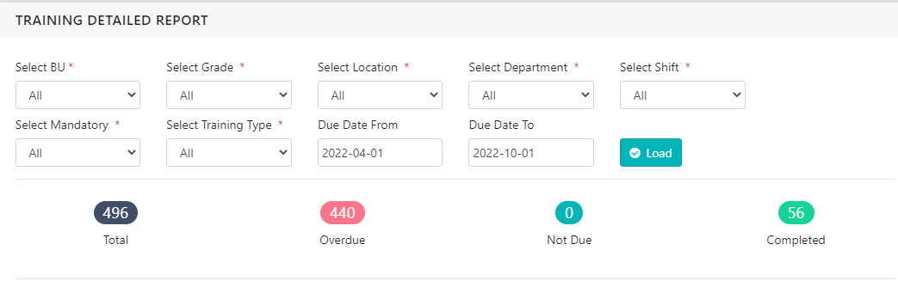

1. Approx. in total 27 training identified, out of them approx. 19 delivered.
2. After remove tools as users (employees) approx. 468 are total trainings items for employees instead of 496.
3. In above chart each training and each employee wise total 468 item identified. Out of that approx. 56 delivered. This means that some trainings are not completed for all corresponding employees. Those are completed for some.

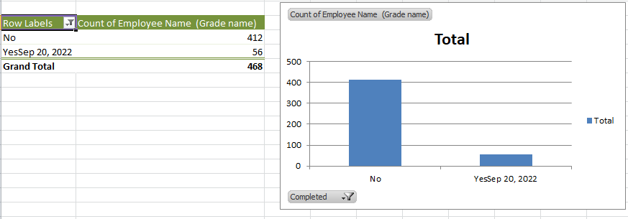

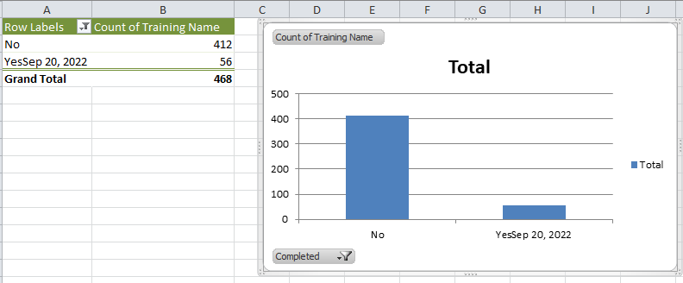

1. If we see this training wise, for example below training assigned to 29 employees, but it is completed for 18 only yet.

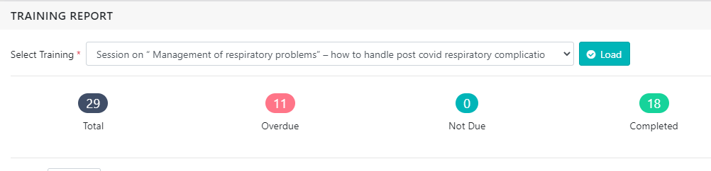

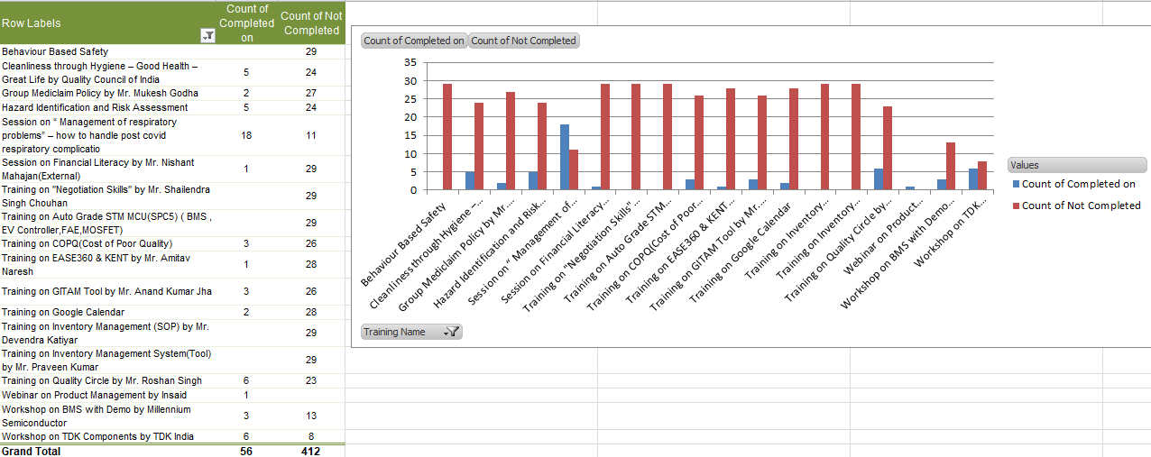

1. And if we see employee wise, for example for below employee total 21 trainings identified and assigned, out of them 5 completed, 13 are overdue and 3 are not due by dates.

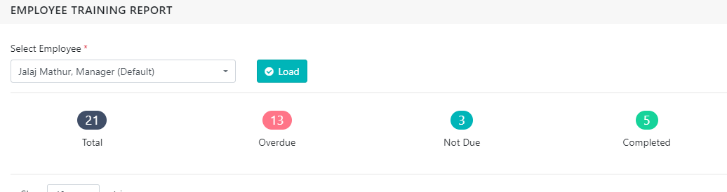

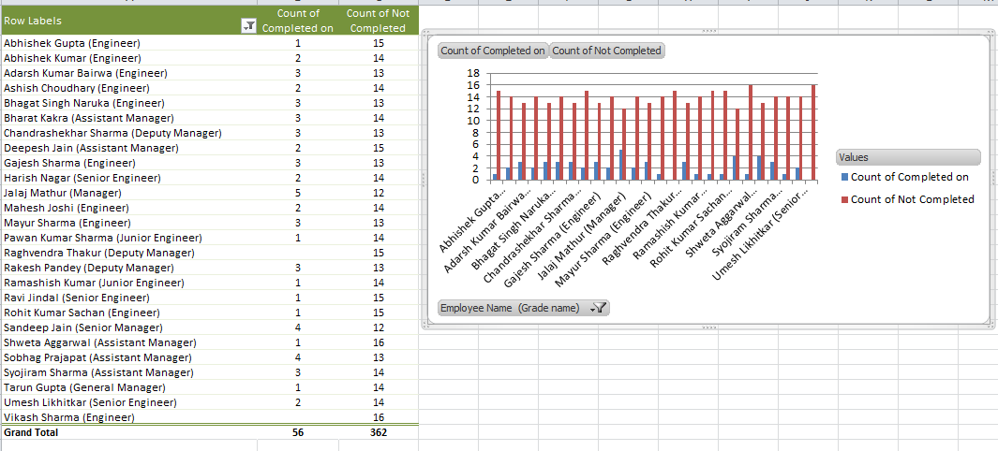

Coverage of each employee is satisfactory; each active employee attended at least one training except Mr. Vikash Sharma.

### Conclusion and Proposed Corrective & Preventive Actions

1. Although coverage is satisfactory, but overall speed till date is not up to mark, to increase the speed talked to training coordinator and understood that since last 1-2 months some organizational events were happening like “Azadi ka Amrit Mahotsav”, “Green & Clean Day” and “Innovation Day” etc. And as HR team member Training Co-coordinator was engaged in those activities.
2. As Mr. Vikash Sharma not joined any identified training yet, so will highlight this to training coordinator and Vikash himself also.
3. Also for training feedback data asked from training coordinator for analysis.

1. https://gil.einframe.com
2. https://gil.einframe.com